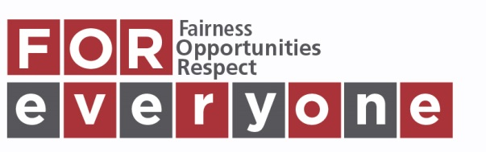
Equality Impact Assessment Form

Department/Section: HR and Organisational DevelopmentDate of Assessment: 13/11/2019 Review Due: April 2021

Author/Owner: Anna Maria KaczmarekSignature: anna.kaczmarek.perth@uhi.ac.uk Date: 13 November 2019

Step 1
Aim of proposed activity/decision/new or revised policy or procedure: This integrated report outlines our progress with meeting the General Duties and Equality Outcomes associated with the Equality Act 2010 and other relevant legislation. It is a corporate report and recognises that the core importance of our Equality Outcomes 1, 2 and 3 to the fulfilment of our Equality Outcomes 4 and 5. Furthermore, section on Equality Outcome 3 forms our basic Workforce Profile 2017-2019 thus allow us to provide an update to our Annual Employee Profile of 2017.  This report is complemented of:  a) Appendix 1 detailing progress we have made at an operational level within our diverse sectors and teams  b) Appendix 2 listing and mapping all our equality actions, timescales and policies and aligning these to allow for a more coordinated and streamlined approach to our Public Sector Equality Duties. | New
 | Revised
 | Existing

Who will be affected?  Staff, students, visitors, and external organisations/partners. | Who will be consulted?  Perth College UHI Teams, AST, our contractual partners, and HISA. | Evidence available:  staff and student surveys, corporate policies, strategies and monitoring and evaluation reports, internal data from HR, payroll and student record systems, UK equality evidence.

Step 2
Potential Positive/Negative/Neutral Impact Identified.  P, N, N/I | Age | Disability | Gender Reassignment | Marriage/Civil Partnership* | Pregnancy and Maternity | Race | Religion or Belief | Sex | Sexual Orientation
Eliminating Discrimination. | P | P | P | P | P | P | P | P | P
Advancing Equality of Opportunity. | P | P | P | P | P | P | P | P | P
Promoting Good Relations. | P | P | P | P | P | P | P | P | P
Summary of EIA Outcome – please tick
No further action to be carried out.
Amendments or changes to be made.
Proceed with awareness of adverse impact.
Abandon process – Stop and Rethink.
Step 3 Action to be taken
The report provides an up to date evidence of the current status of systems, processes and provides update on emerging and future activities including concrete actions the organisation commited to. The report itself thus proactively reviews systems, identifies areas for further development and outlines what actions are taken and will be taken to advance general duties and meet equality outcomes. All these will have a positive impact on all Protected Characteristics and on human rights other than the "non-discrimination" right.

Please forward completed EIA forms by e-mail to Helen Duncan, Equality and Diversity Adviser.

