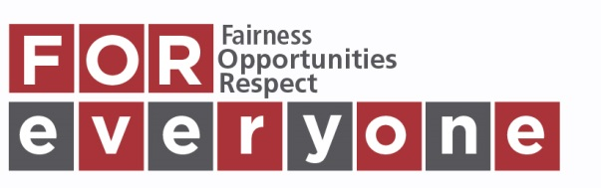
Equality Impact Assessment Form

Department/Section: FOI Date of Assessment: 17/06/19Review Due: n/a

Author/Owner: FOI OfficerSignature: Kirsty CampbellDate: 17/06/19

Step 1
Aim of proposed activity/decision/new or revised policy or procedure: Review of records management policy, in relation to SQA retention periiods, and inclusion of college areas currently missing from appendix 3. | New
 | Revised
 | Existing

Who will be affected?  All staff who deal with records management, staff who process and store data, data subjects. | Who will be consulted?  Relevant college managers and UHI SQA Officer. | Evidence available:  Data Protection Act 2018, FOI(S)A 2002.

Step 2
Potential Positive/Negative/Neutral Impact Identified.  P, N, N/I | Age | Disability | Gender Reassignment | Marriage/Civil Partnership* | Pregnancy and Maternity | Race | Religion or Belief | Sex | Sexual Orientation
Eliminating Discrimination. | P,N | P,N | P,N | P,N | P,N | P,N | P,N | P,N | P,N
Advancing Equality of Opportunity. | P,N | P,N | P,N | P,N | P,N | P,N | P,N | P,N | P,N
Promoting Good Relations.
Summary of EIA Outcome – please tick
No further action to be carried out.
Amendments or changes to be made.
Proceed with awareness of adverse impact.
Abandon process – Stop and Rethink.
Step 3 Action to be taken
There is a potential for negative, as well as positive, impact in following records management procedure. There could be negative impact for a data subject if we dispose of information which may help them in, for example, a court case, or a child custody issue. On the other hand, there is potential for positive outcome if we have disposed of records which may be unhelpful to the data subject in similar circumstances. As this is a statutory duty under the DPA 2018, and the FOI(S)A 2002, there is little we can do to mitigate for either of those circumstances. Adherence to the records management policies ensures that we can carry out our duties under these acts in a robust manner, as regards our policy and procedure in the event of complaint.

Please forward completed EIA forms by e-mail to Helen Duncan, Equality and Diversity Adviser.

